**Setup elastic agent on remote server and enroll it into fleet server**

1. **Elastic Agent on Remote EC2**

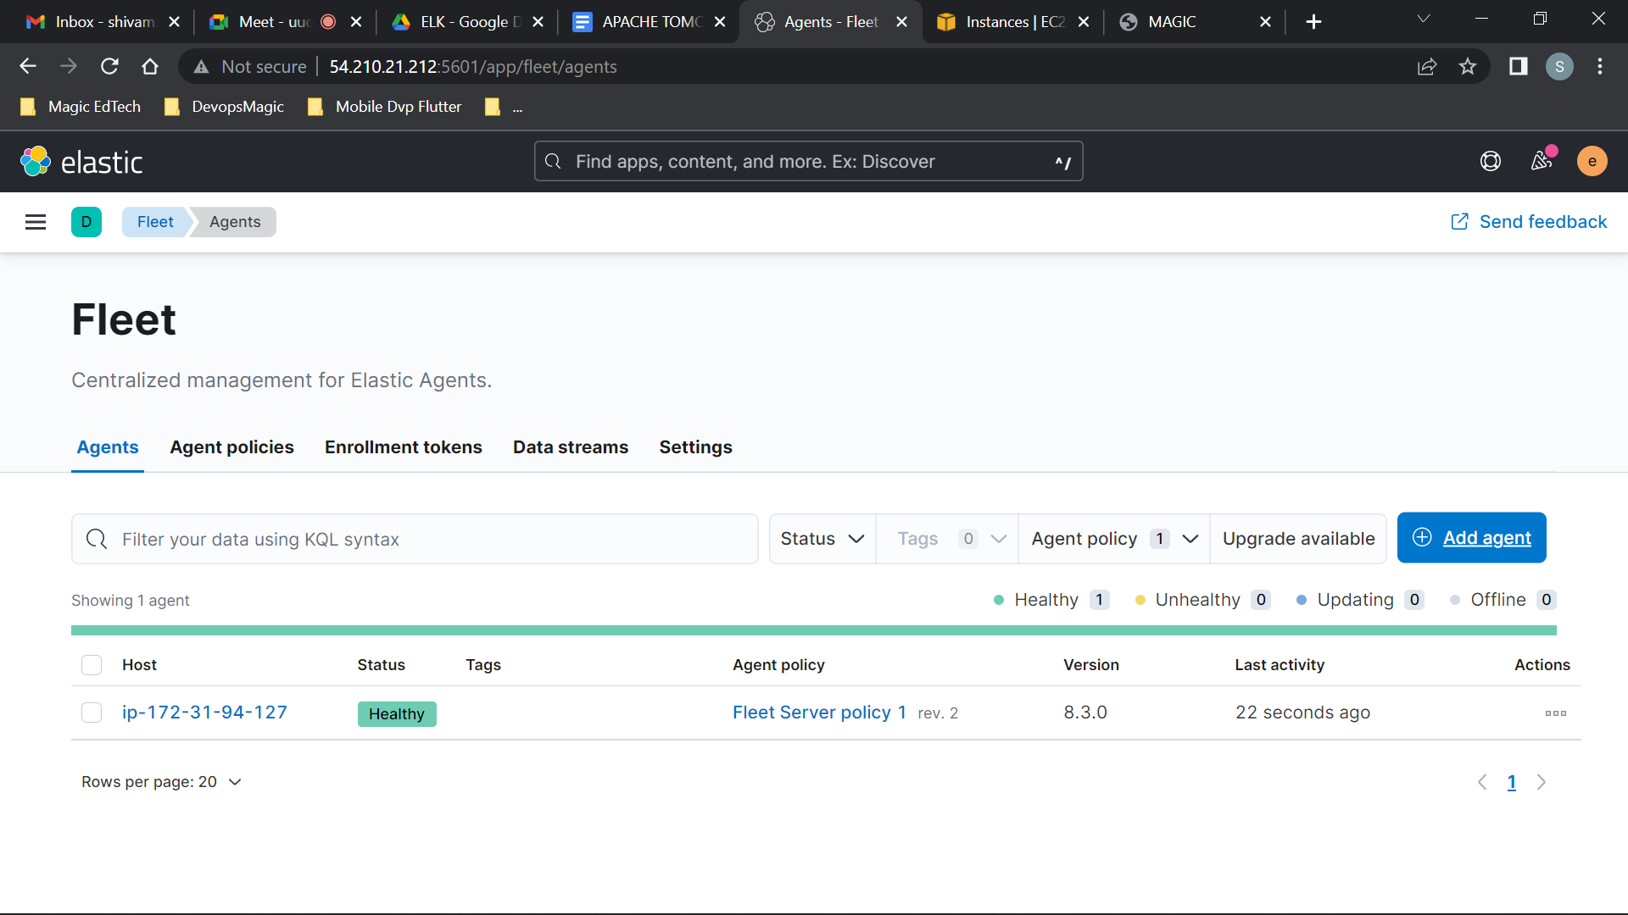

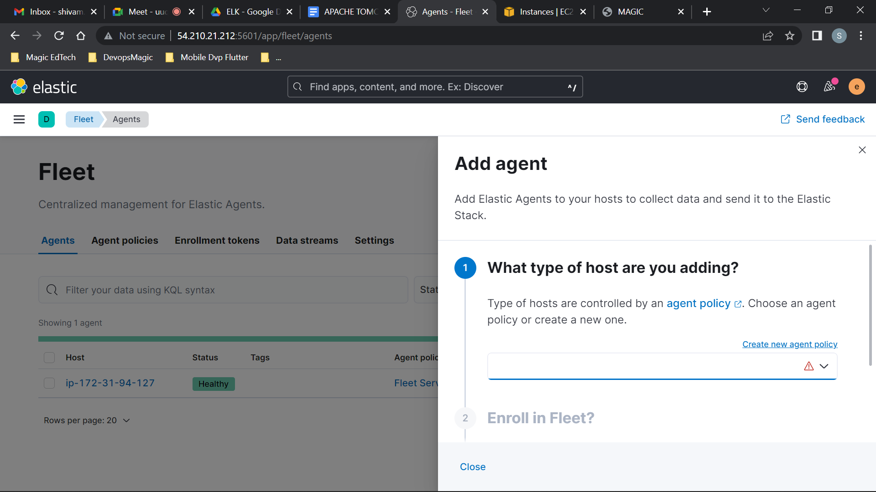

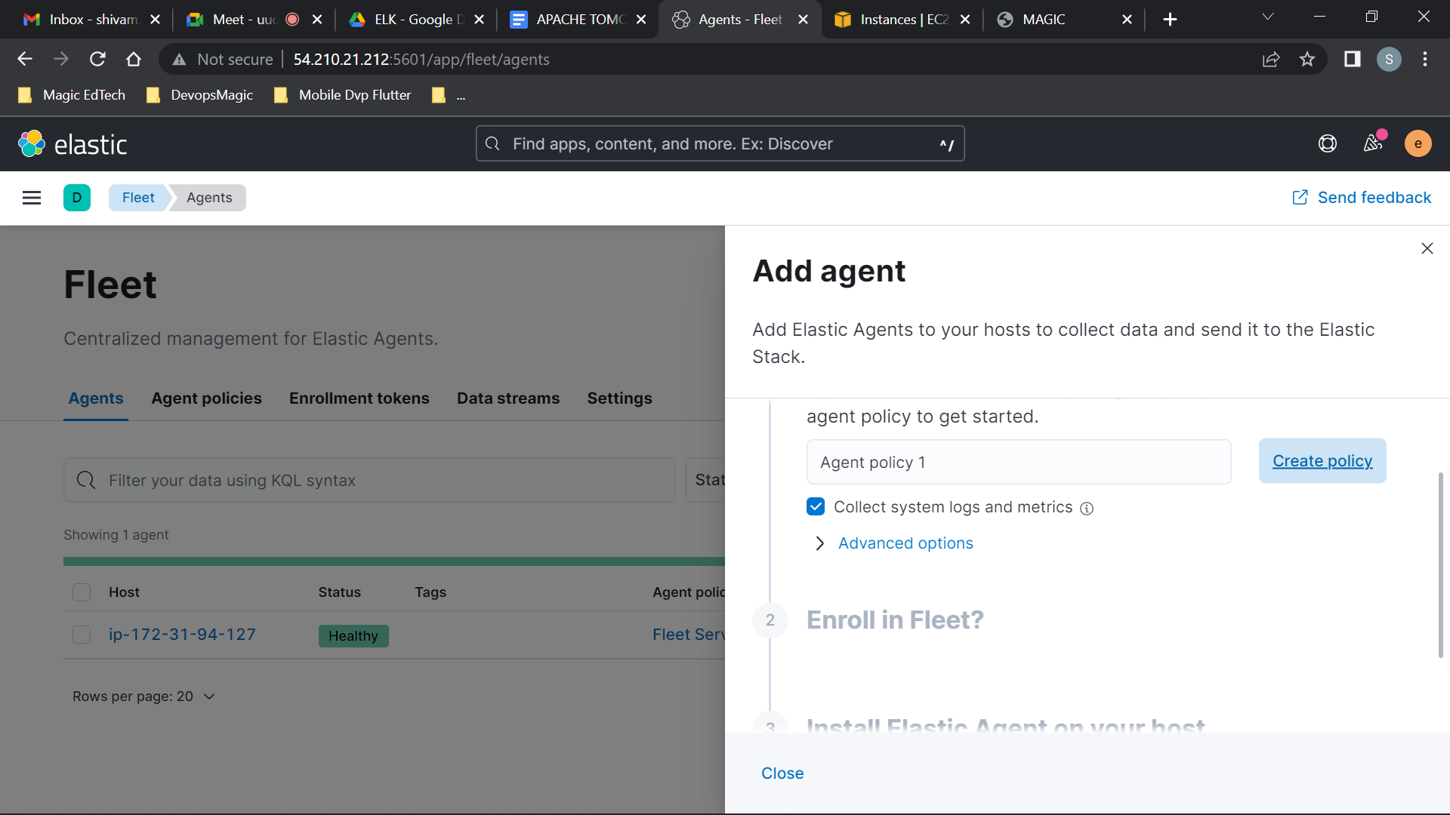

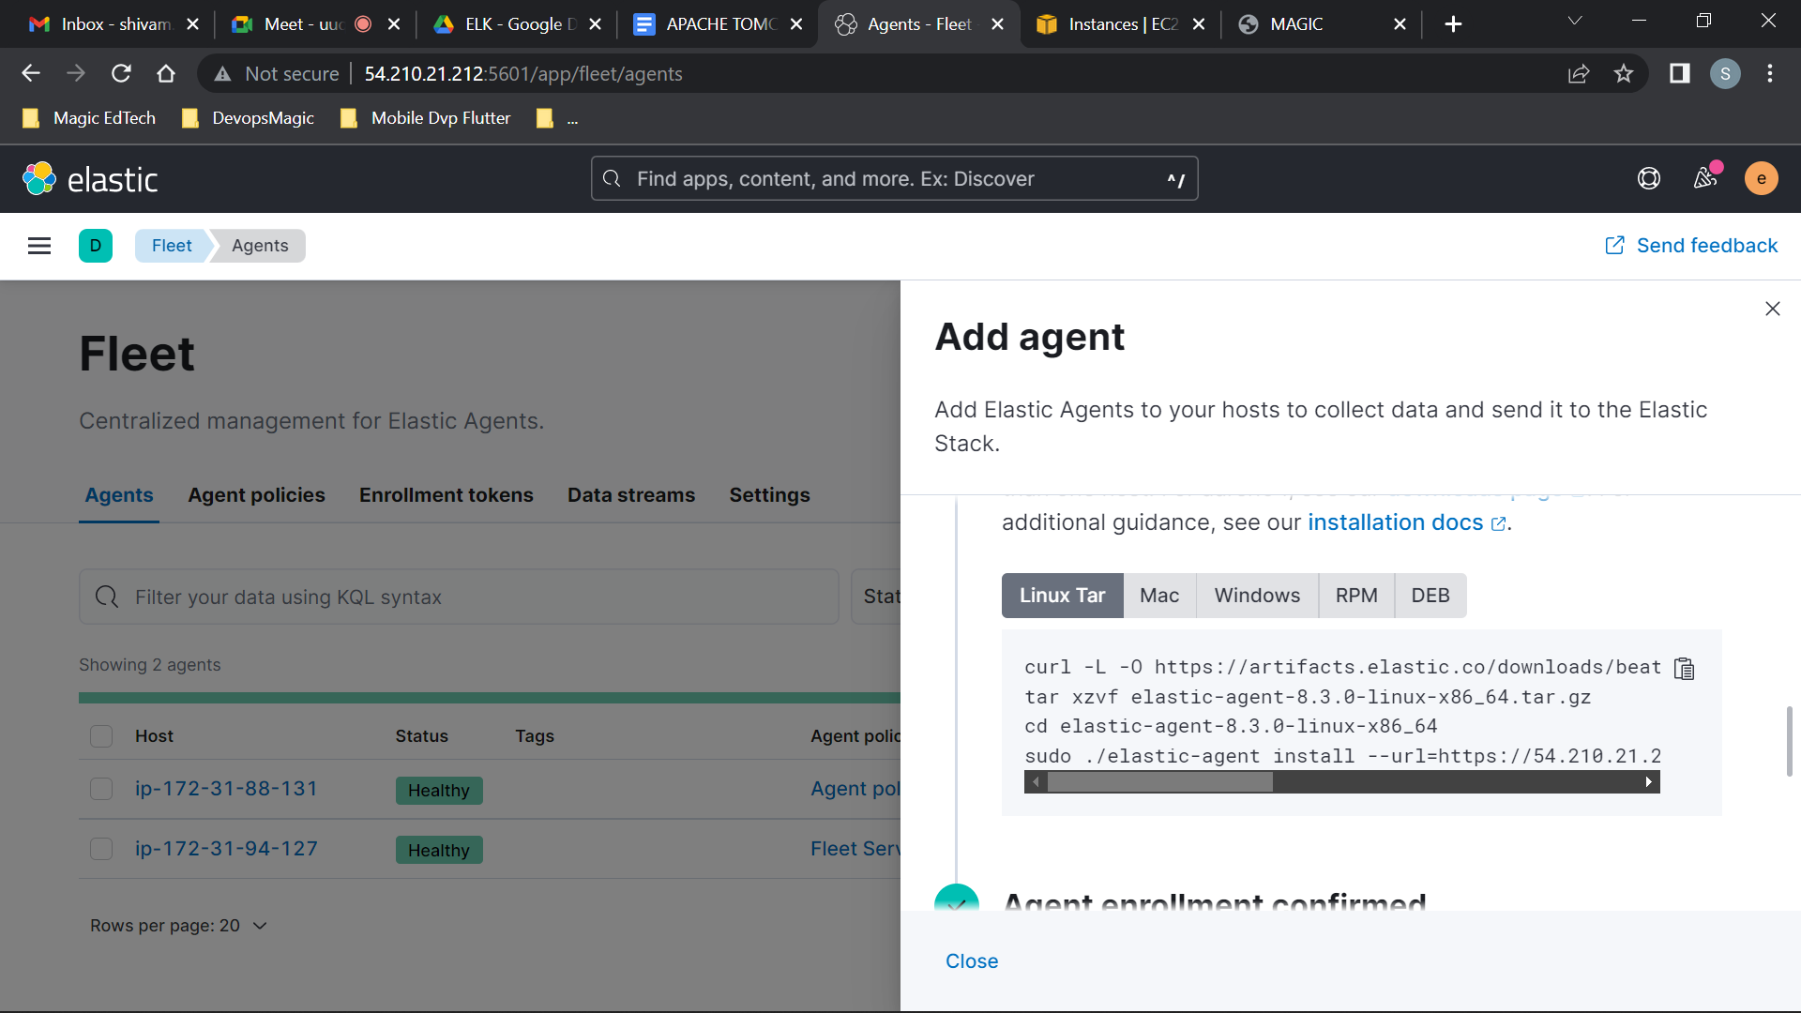

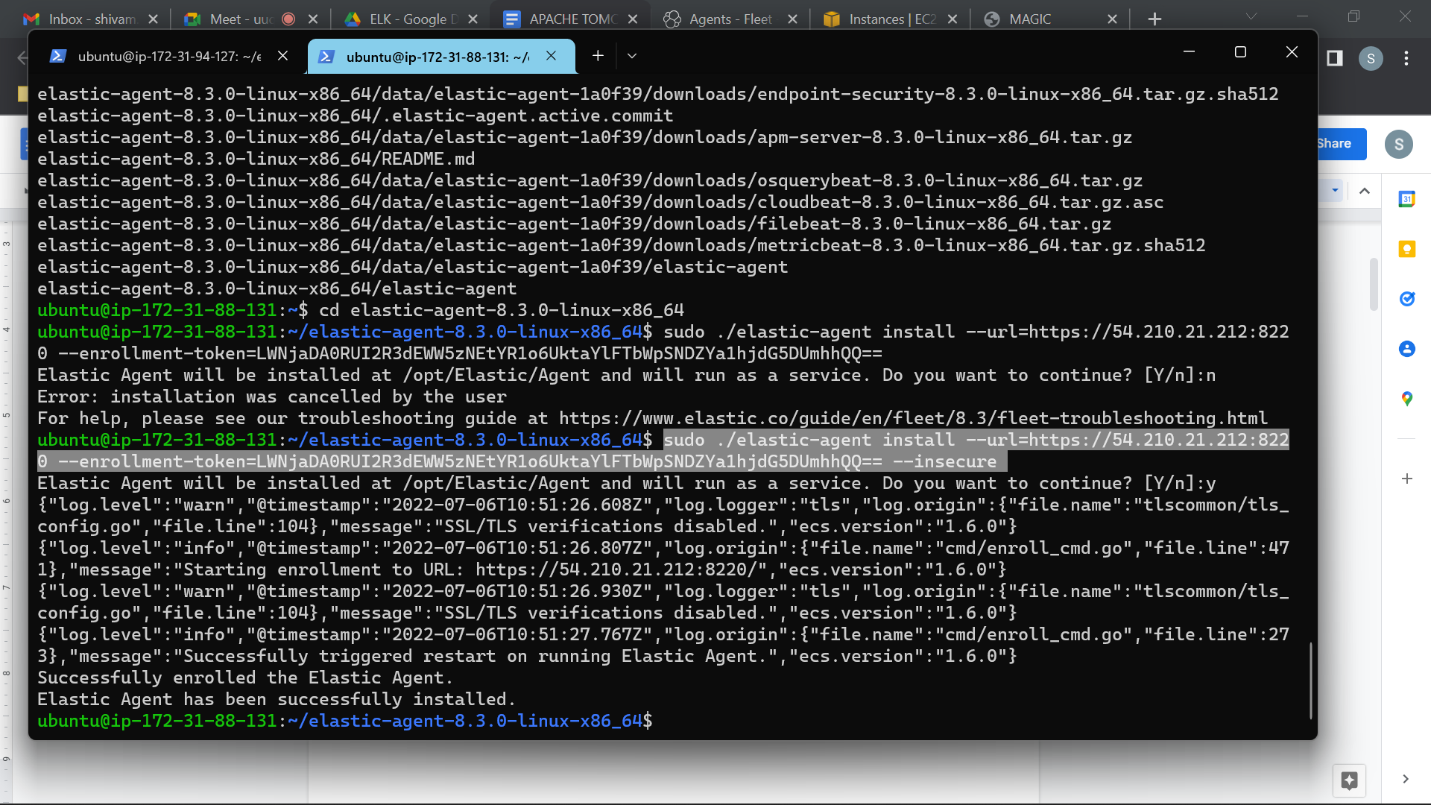

***Add --insecure at the last in the ./elastic-agent install command.***

***Quick start – Fleet Server will generate a self-signed certificate. Subsequent agents must be enrolled using the --insecure flag. Not recommended for production use cases.***

***Production – Provide your own certificates. This option will require agents to specify a cert key when enrolling with Fleet***

REMOTE AGENT DASHBOARD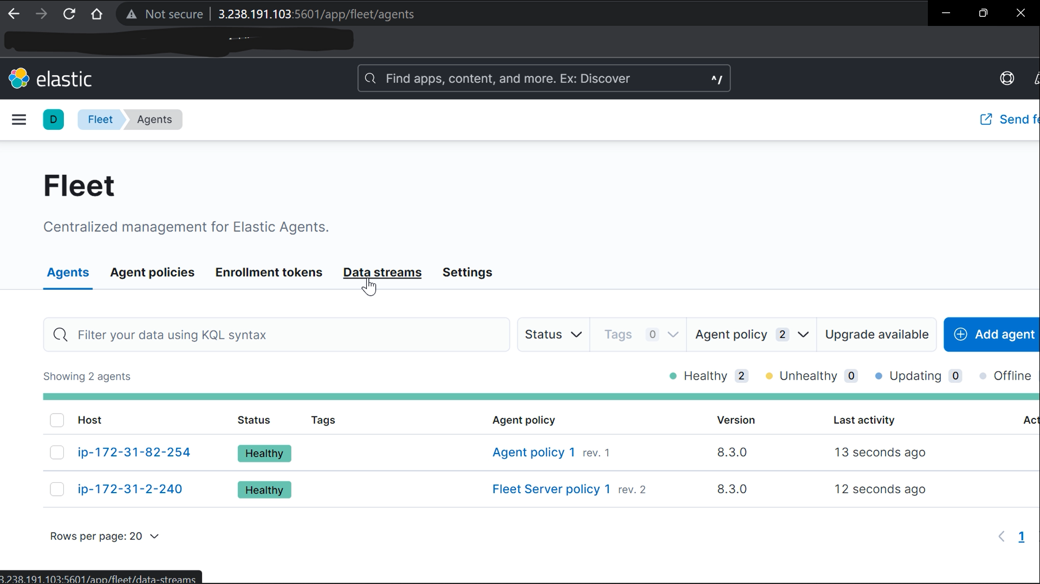

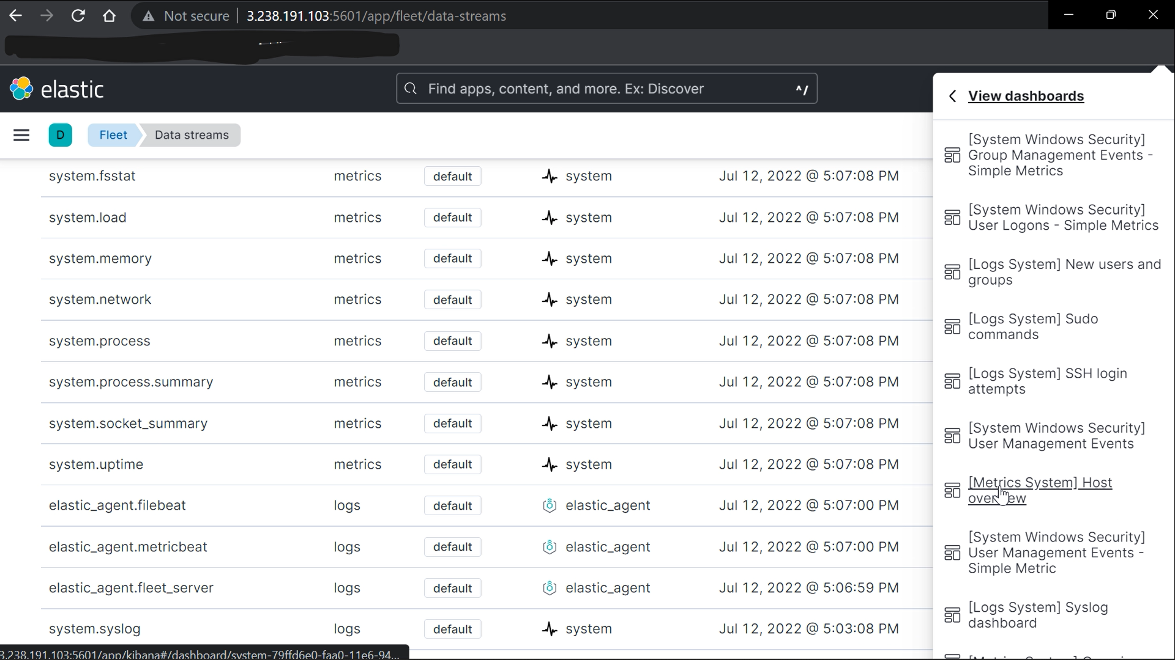

Sort the data using agent Name.

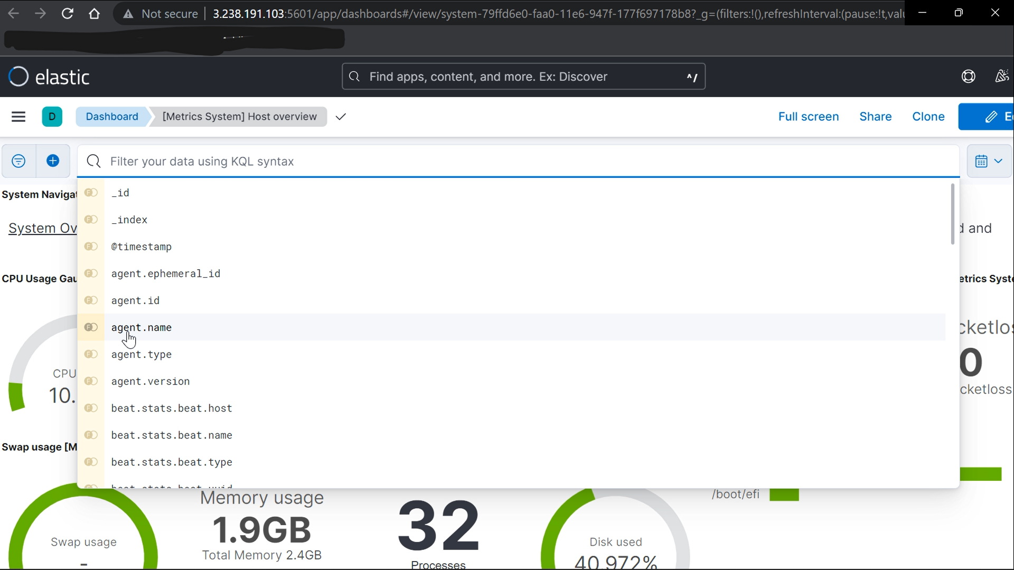

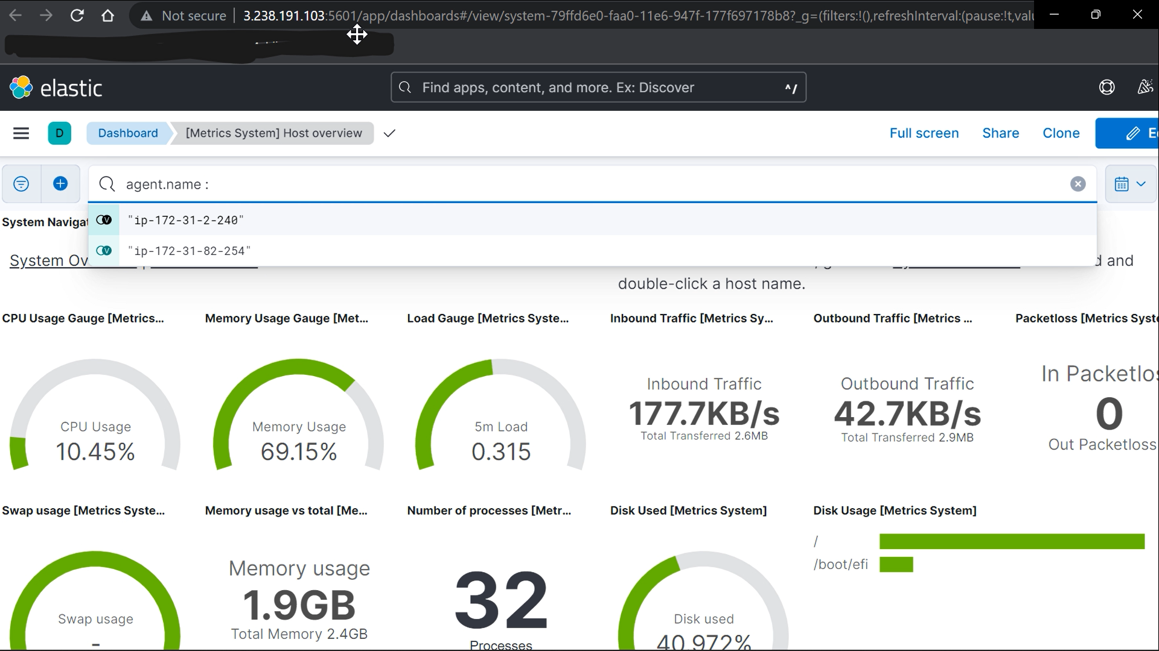

HIT ENTER

